Prerequisitions
- working google account
- credit card prepared

Google Account
- log into google or create account here https://accounts.google.com/signup/v2/webcreateaccount

Procedure
API key (if you prefer video manual please watch this one: https://youtu.be/9ImLCQBj9SE)
- go to https://cloud.google.com/maps-platform/
- click on Get started
- click create billing account and click agree and continue
- supply all informations in the form and click start my free trial
- make sure you are on the APIs & Services page (click the burger icon at the top left to open the navigation menu. Then select the APIs & Services option)
- click + Create project call it descriptively for yourself: e.g: "grab maps boxdice" and click Create.
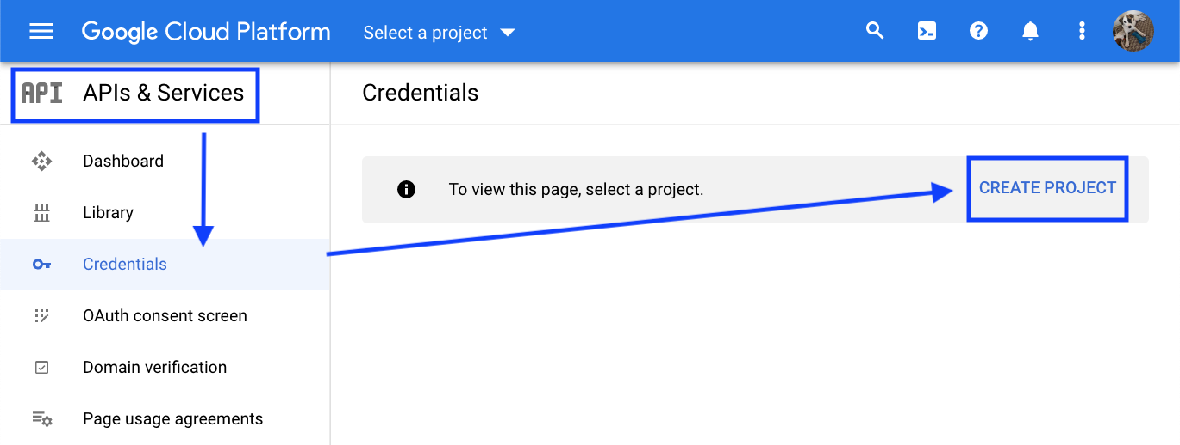
- on the Credential's tab, click + Create Credentials > API key
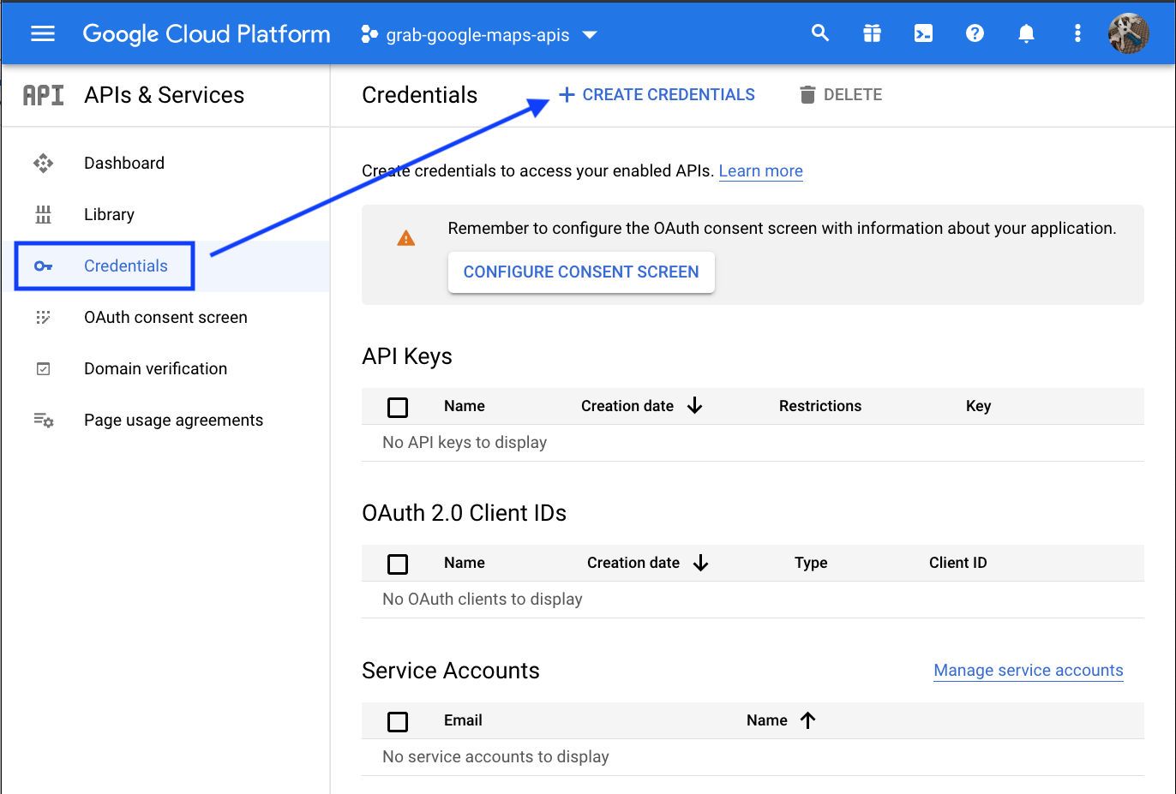
- copy the API KEY saving this for later, to send an email to B+D support
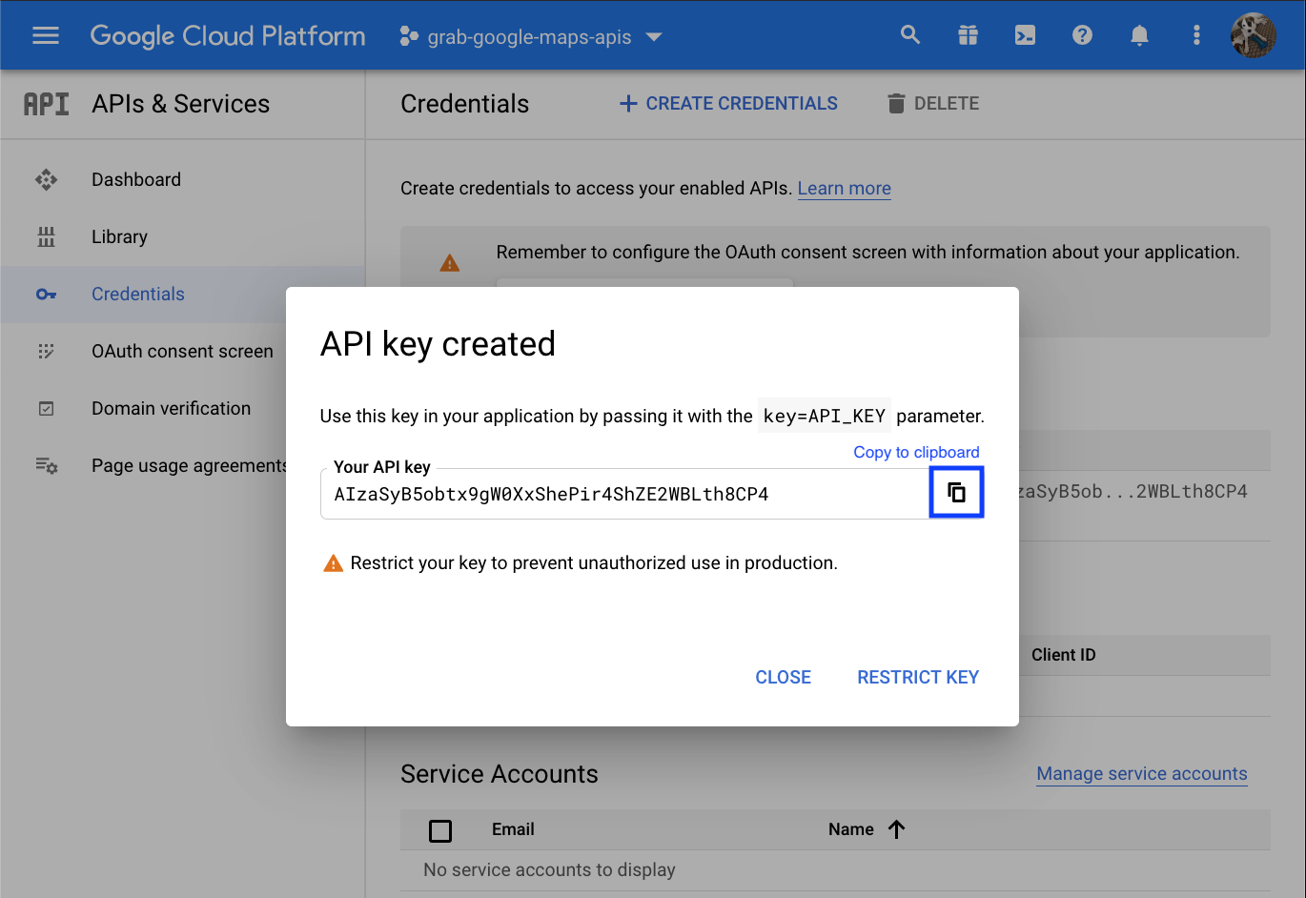
- click on Restrict Key (if the API key pop up is no longer there,​ click the pencil icon to the far right of the API Key​, and this will take you to the Restrict and Rename API key page.
- under Application restrictions select: HTTP referrers (web sites)
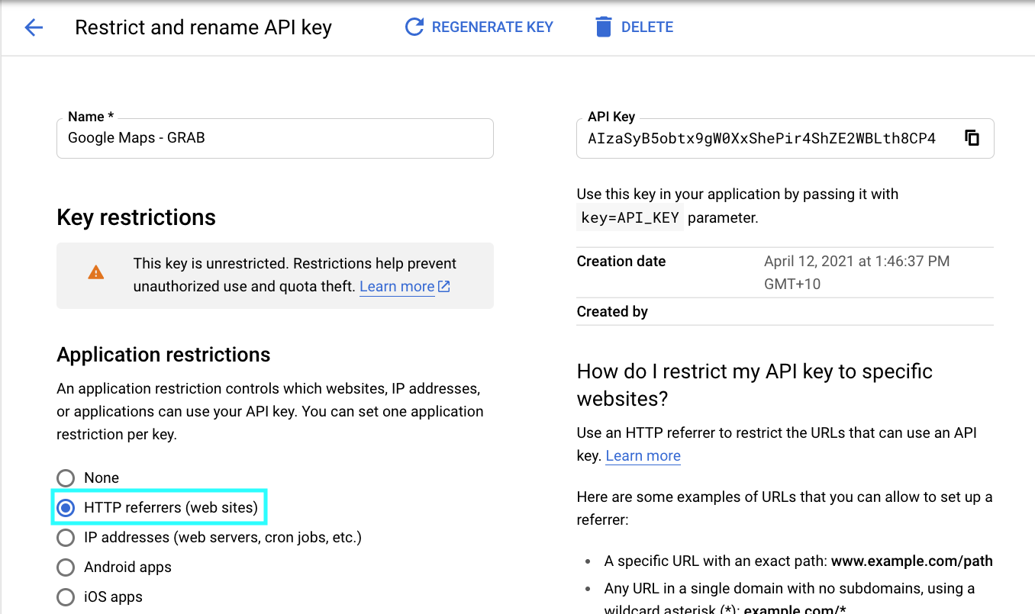
- next, under Website restrictions click on Add An Item, and fill out in this format; examplewebsite.com.au/*
(This is without http/https)
NOTE: you will need to add three items here (with an asterisk (star) symbol just like in the below example)
  - First one: the boxdice system URL. Do not forget asterisk (star) symbol at the end, otherwise the API will be enabled only on your homepage.
  - Second one: your live URL. Also include asterisk (star) symbol as per above.
  - Third one: your live URL. Again asterisk (star) symbol as per above and another asterisk (star) symbol at the beginning as a URL could contain www or a subdomain.
(note the full stop after the first asterisk (star) symbol for the third item)
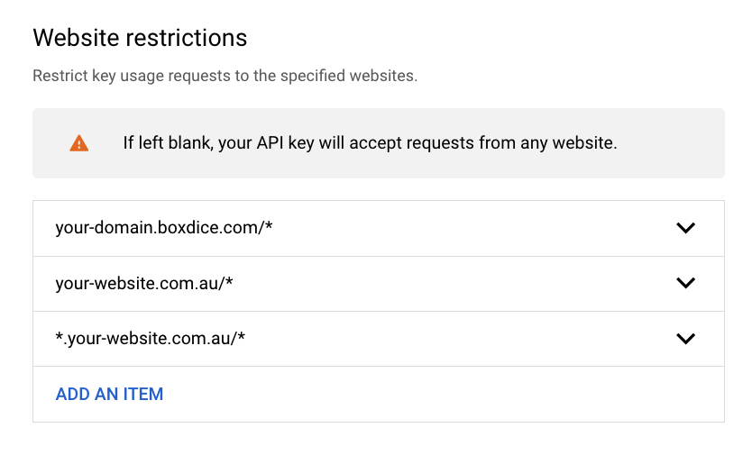
Long story short, this is how the URL's should look like:
  - example.boxdice.com.au/* (this is your Box+Dice URL)
  - exampleproperties.com.au/* (this is your live website URL)
  - *.exampleproperties.com.au/* (this is your live website URL. Note the full stop after the first asterisk (star) symbol)
- then hit save

