This article provides a step by step guide for an Administrator to set up SSO in Azure for Box+Dice. After it has been set up individual users who have an Azure account will have the ability to sign in to Box+Dice using their Azure credentials, meaning separate Box+Dice credentials are no longer required.
1. Sign in to the Azure portal. Select the Directory + Subscription icon in the portal toolbar and select the directory that contains your Azure AD B2C tenant. In the Azure portal, search for and select Azure AD B2C:
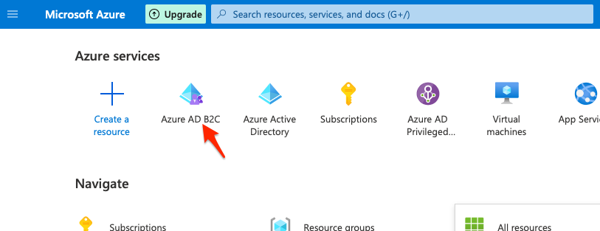

2. Then go to “Applications” and create a “New Registration”:
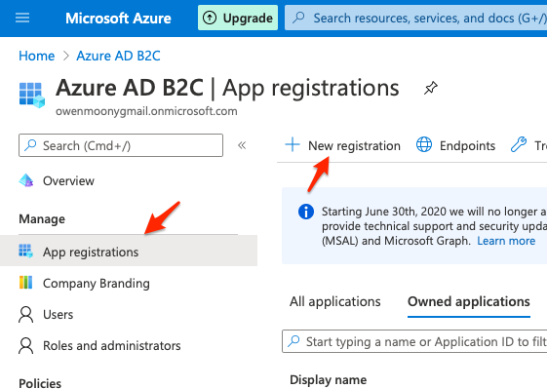

3. Create the application giving it a name of your choice and then click on the “Register” button:
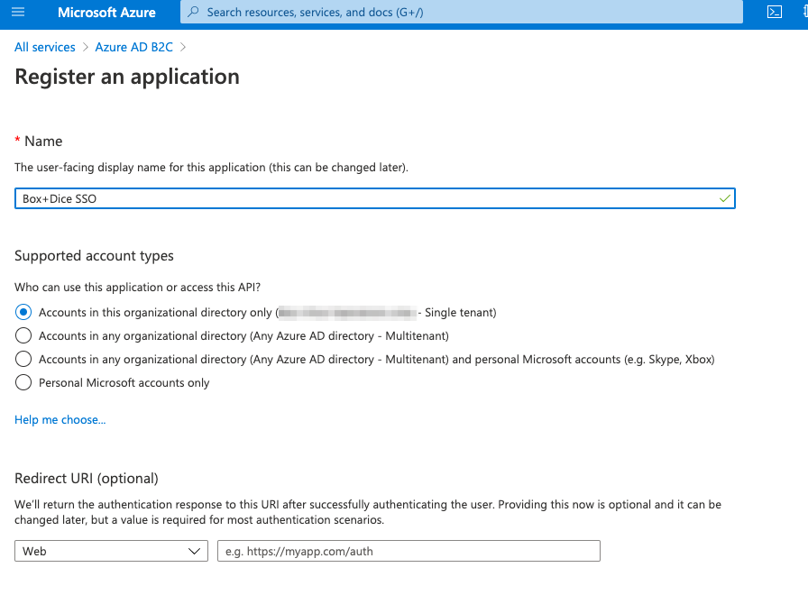

4. Add the “Client Secret” and set expires to 'Never':
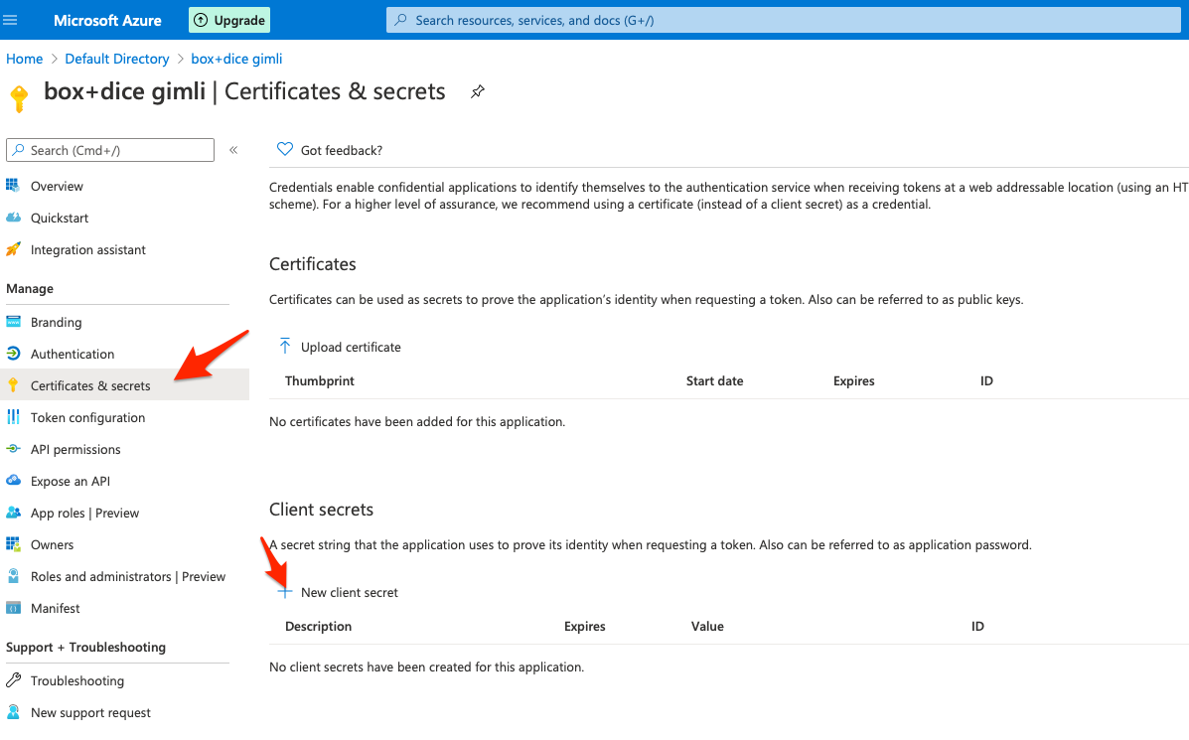
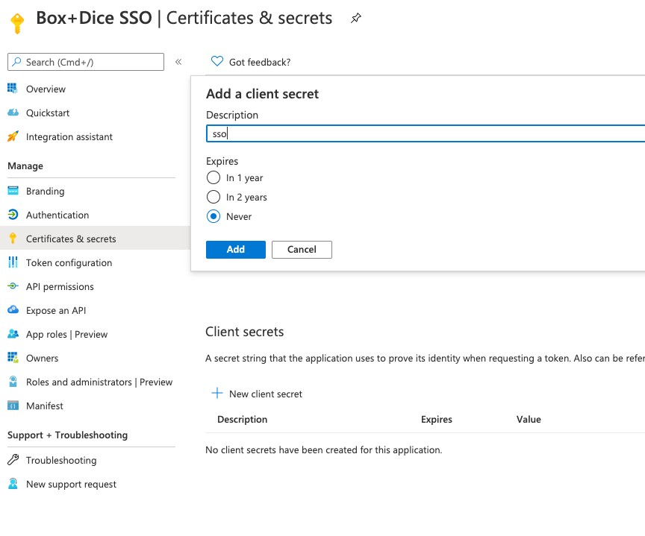

5. Copy the 'Client secret' and in Box+Dice add it as the 'Provider Secret':
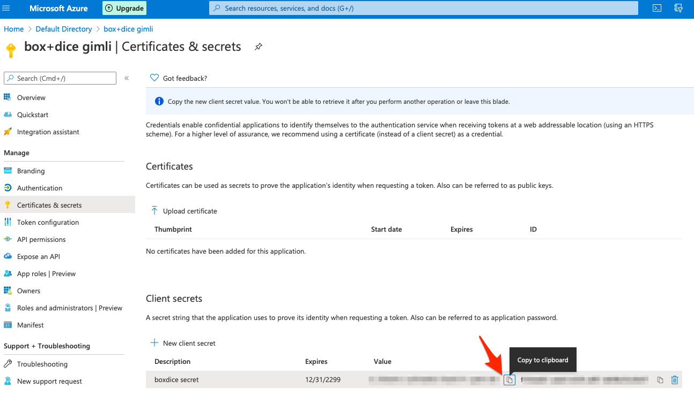

5.1. Add the 'Client Secret' here:
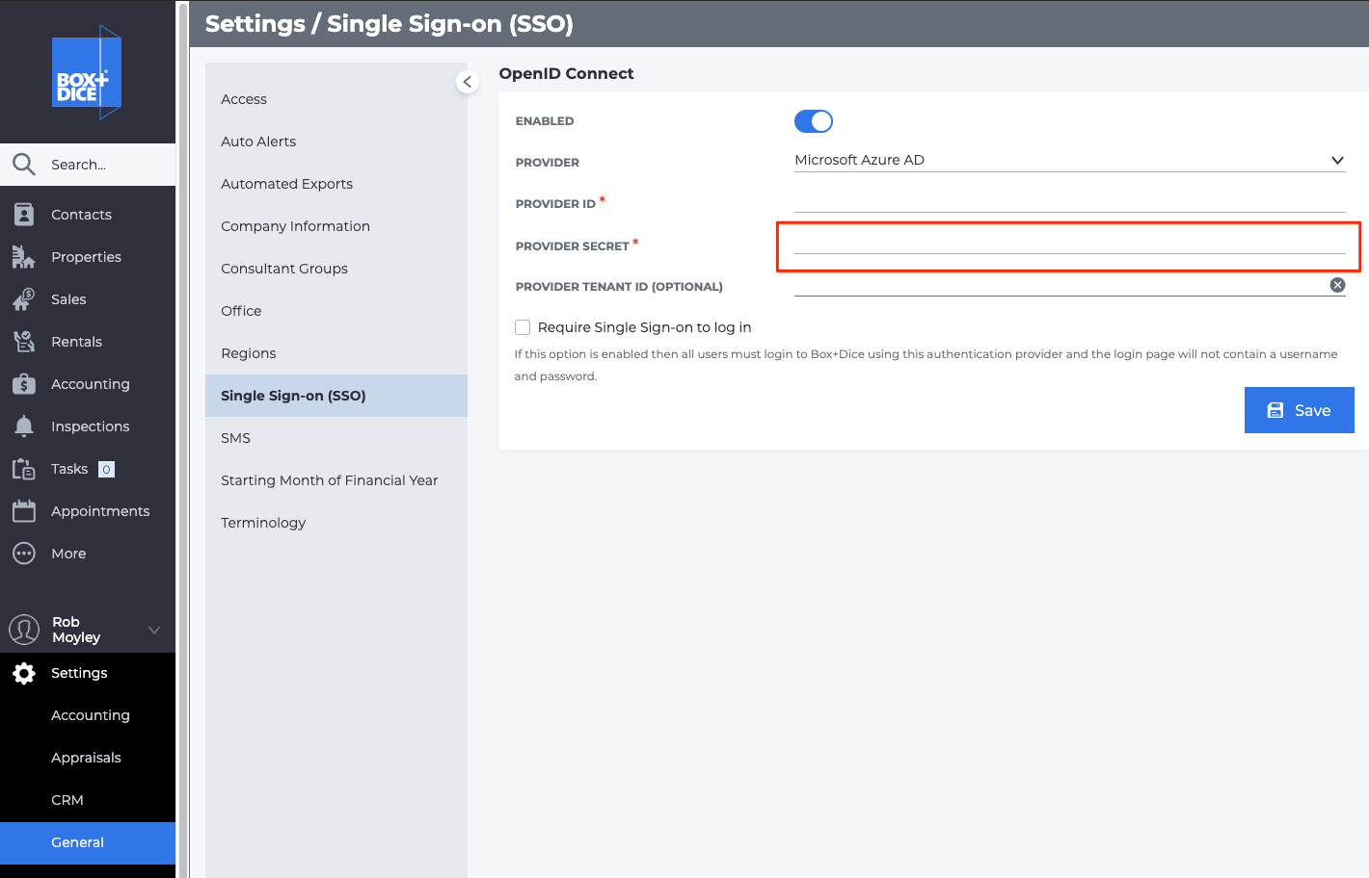

6. Copy the 'Application (client) ID' and in Box+Dice add it as the 'Provider ID':
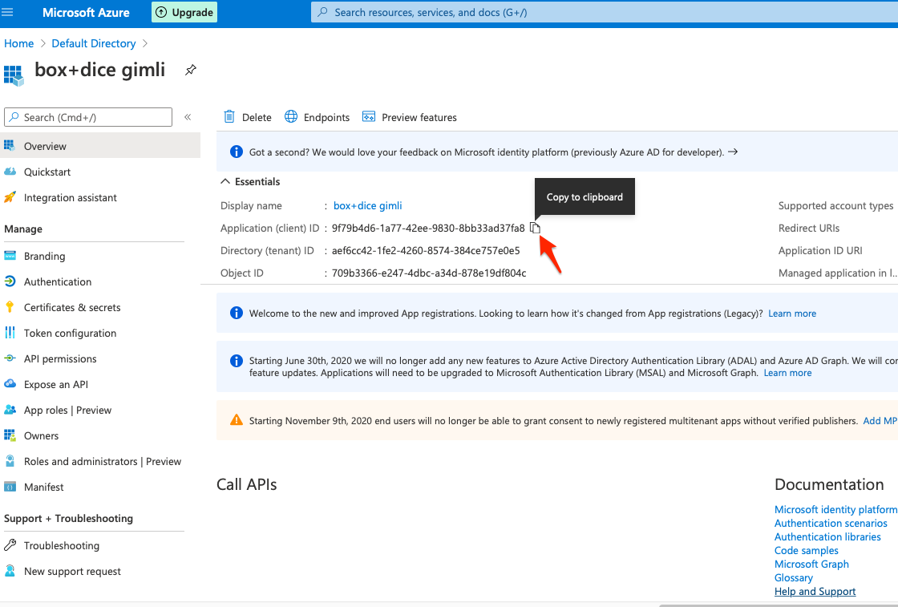

6.1 Add the 'Application (client) ID' here:
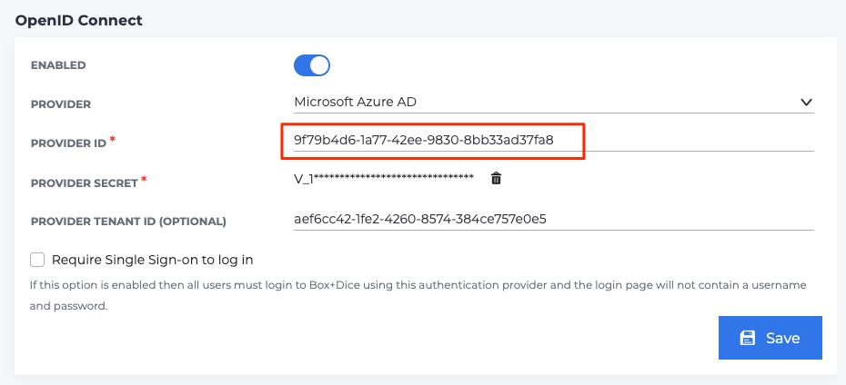

7. Copy the 'Directory (tenant) ID' and in Box+Dice add it as the 'Provider Tenant ID (Optional)':
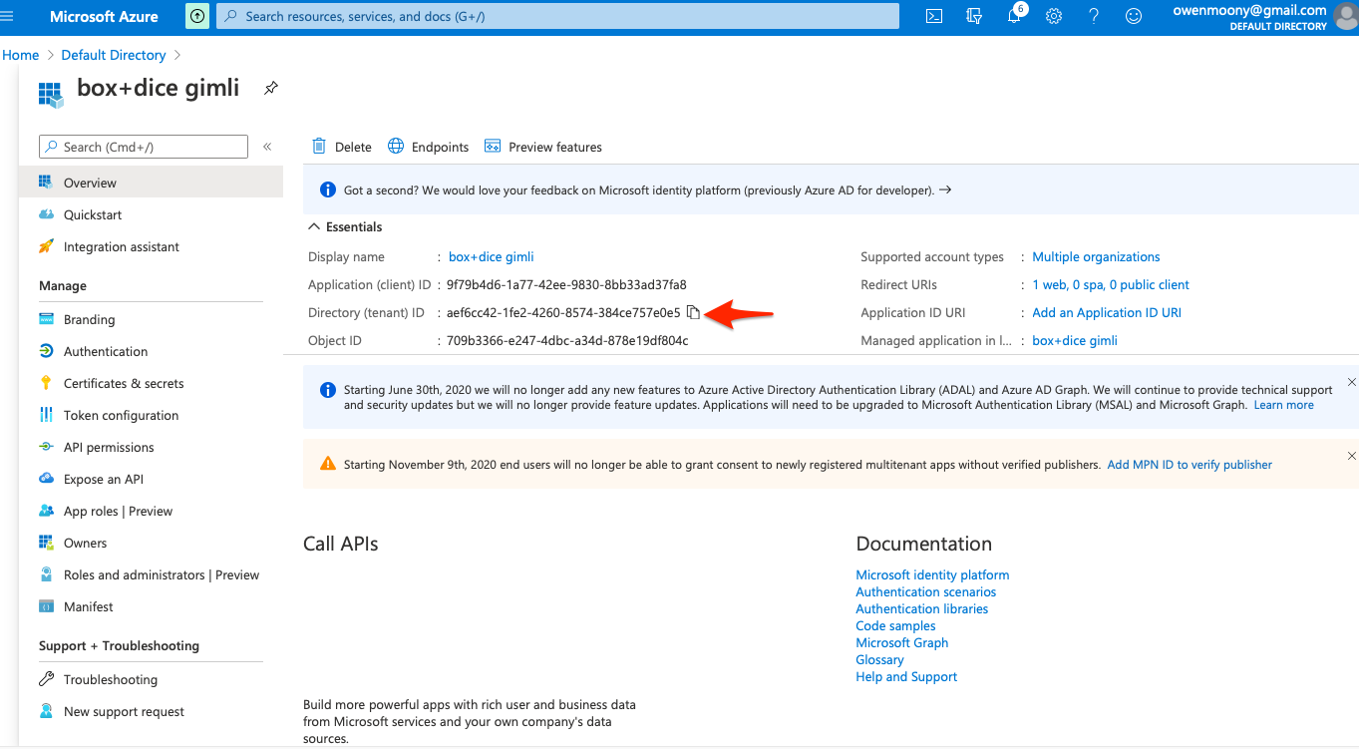

7.1 . Add the 'Directory (tenant) ID' here:
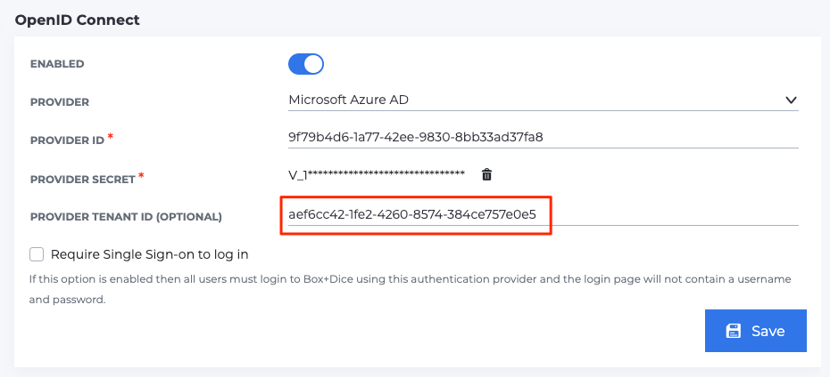

8. Add the redirect URLs:
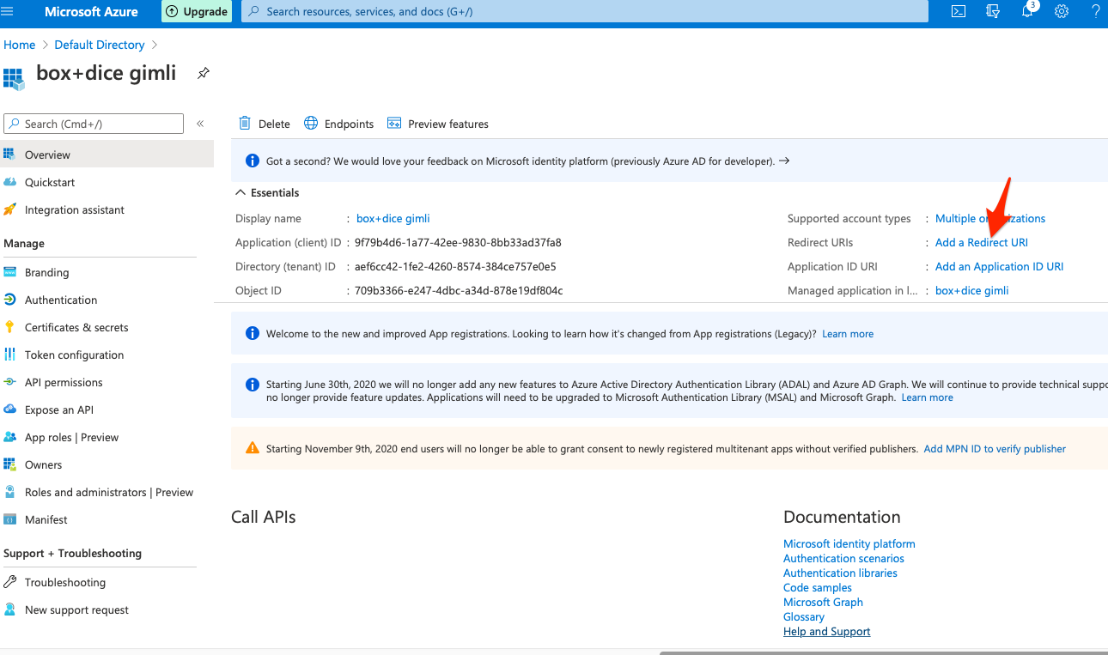

9. Add a platform:
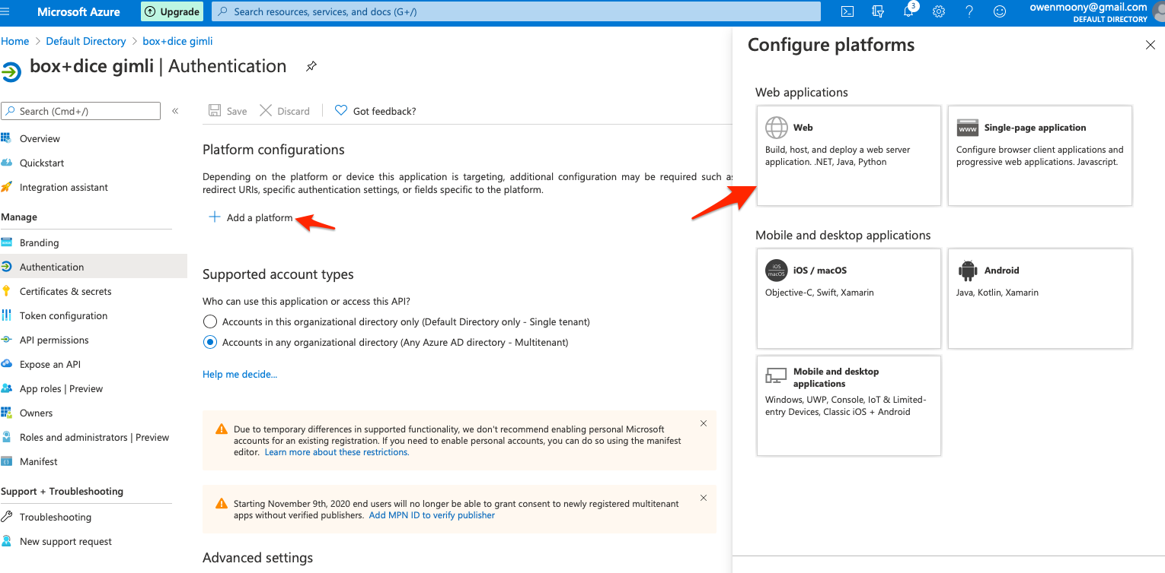

10. Fill in the Redirect URIs and Logout URL and check the two implicit grant flows:

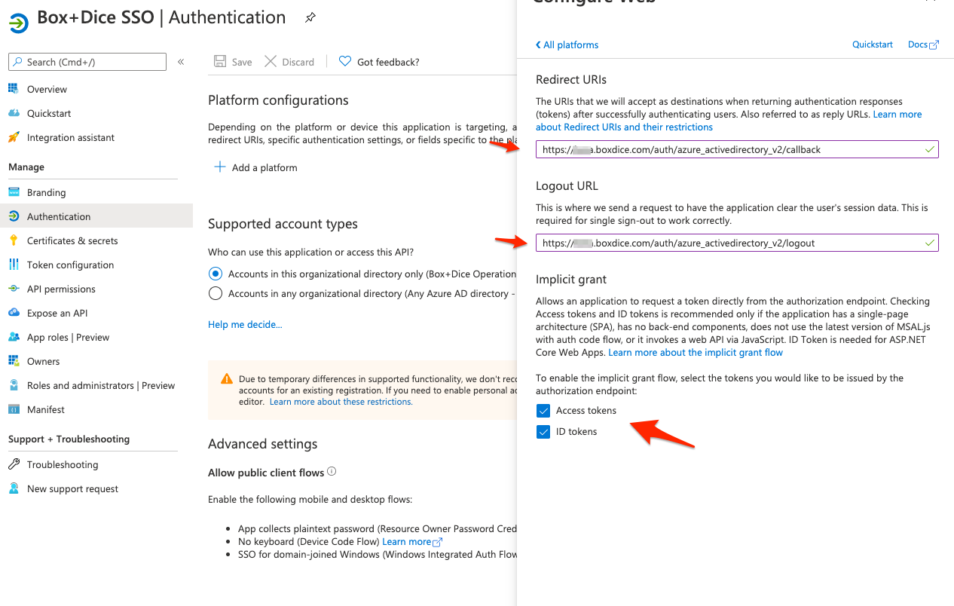
- Ensure you put in exactly Redirect URLs (must include https):
  - https://{your subdomain}.boxdice.com/auth/azure_activedirectory_v2/callback
  - https://{your subdomain}.boxdice.com.au/auth/azure_activedirectory_v2/callback
(where {your subdomain} is the subdomain you use to access Box+Dice)
- Ensure you put in exactly Logout URLs (must include https):
https://{your subdomain}.boxdice.com/auth/azure_activedirectory_v2/logout
(where {your subdomain} is the subdomain you use to access Box+Dice)
11. Click 'Configure' and then save the SSO config in Box+Dice and you should be ready to sign in to Box+Dice using Microsoft.

